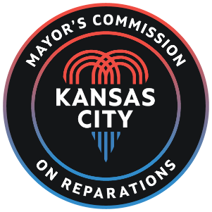

Mayor’s Commission on Reparation
_{Presents:}
Black Audit Project KC – RESULTS!!!
_{Where:} Zoom https://columbiauniversity.zoom.us/j/93861024466?pwd=Q3ZwUDZ0YzhZdmlxN1RVc054Wk14UT09
_{Time: 1:00 pm to 2:00 pm}
_{Date: May 1, 2024}

